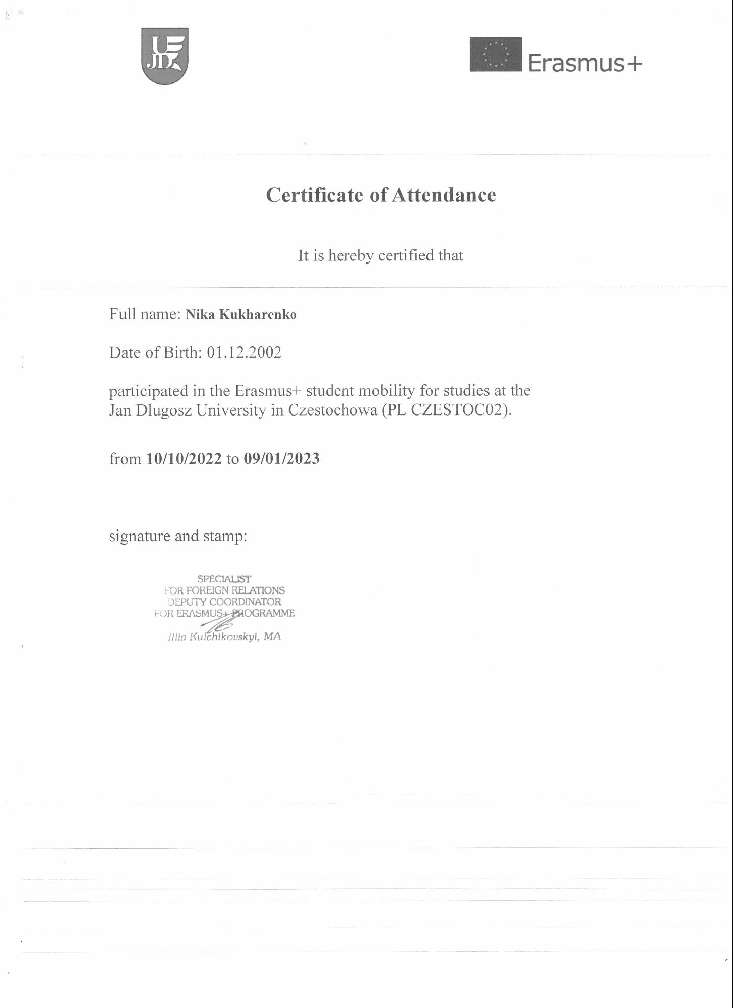
Certificate of Attendance
It is hereby certified that
Full name: Nika Kukharenko
Date of Birth: 01.12.2002
participated in the Erasmus+ student mobility for studies at the Jan Dlugosz University in Czestochowa (PL CZESTOC02).
from 10/10/2022 to 09/01/2023
signature and stamp:
SPECIALIST
FOR FOREIGN RELATIONS DEPUTY COORDINATOR FOR ERASMUS+ PROGRAMME
Illia Kulchikovskyi, MA
Erasmus+

